

American International University-Bangladesh (AIUB)  
**Department of Computer Science  
Faculty of Science & Technology (FST)**

Project Title: ***Software Solutions for Food Waste and Insecurity Problems***

A Software Engineering Project Submitted

By

|  |  |  |  |  |
| --- | --- | --- | --- | --- |
| **Semester: Fall_24_25** | | **Section: M** | **Group Number:05** | |
| SN | Student Name | Student ID | Contribution (CO3+CO4+CO5) | Individual Marks |
| 01 | IBNUL MOHAMMAD ADIB | 22-49124-3 |  |  |
| 02 | AVOY MOLLICK | 23-50066-1 |  |  |
| 03 | RAIYED ZAYED RAKIN | 23-50071-1 |  |  |
| 04 | ANANYA MONDAL | 23-50963-1 |  |  |

The project will be evaluated for the following Course Outcomes



|  |  |  |
| --- | --- | --- |
| **CO3:** ***Select* appropriate software engineering models, project management roles, and their associated skills for the complex software engineering project and evaluate the sustainability of developed software, taking into consideration the societal and environmental aspects** | Total Marks | |
|  | |
| Appropriate Process Model Selection and Argumentation with Evidence | [5 Marks] |  |
| Evidence of Argumentation Regarding Process Model Selection | [5Marks] |  |
| Analysis of the impact of societal, health, safety, legal, and cultural issues | [5Marks] |  |
| Submission, Defense, Completeness, Spelling, grammar, and Organization of the Project report | [5Marks] |  |
| **CO4: *Develop* a project management plan to manage software engineering projects following the principles of engineering management and economic decision process** | Total Marks | |
|  | |
| Develop the project plan, its components of the proposed software products | [5Marks] |  |
| Identify all the activities/tasks related to project management and categorize them within the WBS structure. Perform detailed effort estimation correspond with the WBS and schedule the activities with resources | [5Marks] |  |
| Identify all the potential risks in your project and prioritize them to overcome these risk factors. | [5Marks] |  |
| **CO5:** **Perform as an effective team member or leader in diverse team settings and solve multi-disciplinary problems in the computer science and engineering domain** | Total Marks | |
|  | |
| Taking project responsibility: perform assigned tasks on time independently | [5 Marks] |  |
| Contribution to project group meetings, sharing fruitful ideas | [5Marks] |  |
| Positive attitude towards group work, collaboration, compromise, helping others to understand their project work responsibility | [5Marks] |  |
| Showing respect and value towards other team member's opinion | [5Marks] |  |

Description of Student’s Contribution in the Project work

|  |
| --- |
| Student Name: IBNUL MOHAMMAD ADIB  Student ID: 22-49124-3  Contribution in Percentage (%): 27%  Contribution in the Project:   * Description * System Design Specification * Risk Analysis   _____Ibnul Adib______  Signature of the Student |
| Student Name: AVOY MOLLICK  Student ID: 23-50066-1  Contribution in Percentage (%): 27%  Contribution in the Project:   * Problem Statements and Objectives * Problem Solutions * Requirement Analysis   _____Avoy Mollick______  Signature of the Student |
| Student Name: RAIYEN ZAYED RAKIN  Student ID: 23-50071-1  Contribution in Percentage (%): 27%  Contribution in the Project:   * UI/UX Design * Project Management   __Raiyen Zayed Rakin__  Signature of the Student |
| Student Name: ANANYA MONDAL  Student ID: 23-50963-1  Contribution in Percentage (%): 19%  Contribution in the Project:   * Roles and Responsibilities * Target Users   Ananya Mondal____  Signature of the Student |

# PROJECT PROPOSAL

## Background to the Problem

A Community Food Exchange Platform solution developed that creates a digital marketplace for sharing surplus food items within local communities or between university students. The platform enables users to list, exchange, or donate excess food through a secure interface that includes features such as user verification, profile management, item listing, filtered searching, direct messaging, and transaction confirmation.

Food waste and food insecurity represent two significant challenges in our communities, with households discarding a substantial portion of purchased food while many individuals struggle to afford basic groceries. Traditional food redistribution systems often lack the flexibility and immediacy needed for perishable items. This platform bridges this gap by connecting those with excess food directly to those who need it, while simultaneously fostering community engagement in sustainability efforts. The solution particularly benefits students, residents, and temporary residents who may experience food surplus or scarcity at different times.

## 1.2 **Solution to the Problem**

* **Objectives:**
* **Food Waste Reduction:** A significant portion of food purchased by households goes to waste due to overbuying or mismanagement of groceries.
* **Food Insecurity:** Many individuals and families face food insecurity, struggling to afford basic groceries, particularly in low-income communities.
* **Lack of Community Engagement in Sustainability:** Despite growing awareness of sustainability issues, there are limited local, community-driven solutions that encourage residents to actively engage in reducing waste.
* **Problem Solutions:**

This application solution will be developed on top of a robust technology stack, featuring performance, scalability, and cross-platform ability. Its core programming language will be C#, as it is very object-oriented and will allow for developing a rich in features yet reliable application. SQL Server is intended to be used for the database, effectively storing all user information, food item details, and transaction records, and retrieving it when needed to maintain consistency and ensure security. The application framework shall be .NET Core: high-performance, cross-operational, and supporting a modular architecture that easily maintains upscaling. All put together, this technological stack forms a solid base for an efficient and agile solution that would meet the demands of its end-users, ranging from students to locals to tourists.

* **Basic Functionality:**
  + **Profile Management**: Users will be able to modify profile pic/living area, other users can see this User’s profile statistics too.
  + **Offer Item**: User can offer an Item they have in excess or surplus.
  + **Browse Items**: User feed will be populated by items sorted by area.
  + **Filter Feed**: Users will have options to search or filter by type of item/validity.
  + **Send Offer**: Other Users can respond with an offer of their own.
  + **Confirm Deal**: Users can confirm the exchange. This will take the item off the marketplace and update statistics.
  + **Donate**: Users can also offer Items at no cost.
  + **Monitoring and Reporting**: Algorithms and Admins will be in place to monitor fraudulent activity and respond to the report.
* **Target Users and Benefits:**

This application is designed to target three main groups of users such as students, residents, and tourists or casual users. Students, often managing groceries on tight budget, may lack access to high-quality ingredients, and by the help of this application, designed to enhance the sharing and utilization of resources can attract especially a member in smaller regional capacities. Residents can also use the tool to share surplus food or groceries directly with a neighbor, individual, or family in need which makes resources quickly accessible and available within one's own community. The app is also great for tourists and expats on short-term contracts who are planning a 1-3 month stay at best. The platform allows these users to donate any surplus food before departure, or access available resources while staying on site, reducing waste and encouraging sustainable practices.

* **The Development of Scientific Results:**

The contribution of the EcoExchange project to the development of scientific results is well-identified and documented in several ways:

* **Sustainability and Waste Reduction**: The project addresses the problem of food waste by creating a digital marketplace for sharing surplus food. This contributes to scientific discussions on sustainability, resource optimization, and waste reduction.
* **Food Security**: By providing a platform that helps alleviate food insecurity, the project adds value to research in public health, nutrition, and community support systems, offering a real-world application to mitigate hunger.
* **Community Engagement**: EcoExchange fosters a sense of community and promotes sustainable practices, contributing to social sciences by exploring how digital platforms can enhance community interactions and collective responsibility.
* **Technology and Innovation:** The platform's development using a robust technology stack and methodologies like Extreme Programming (XP) adds to the body of knowledge in software development, agile practices, and digital marketplace innovations.
* **Literature Review on Food Sharing and Waste Reduction Platforms:**

**Existing Studies**

* **Digital Platforms for Food Waste Reduction**: Several studies have explored digital platforms designed to reduce food waste by connecting individuals or organizations with surplus food to those in need. These platforms aim to address the logistical challenges of food redistribution, focusing on real-time exchanges and localized food sharing.
* **Community Food Sharing Applications**: Research into community food sharing applications highlights the social and economic benefits of such platforms. These studies discuss the role of digital solutions in fostering community engagement and support networks, emphasizing the potential for such platforms to strengthen communal ties and provide support during economic downturns or crises.
* **Food Insecurity and Digital Solutions**: Addressing food insecurity through digital means is a growing area of interest. Studies have examined how technology can provide dignified access to food resources, often focusing on the ability of these platforms to reduce the stigma associated with food assistance programs. The use of mobile and web applications to bridge the gap between food surplus and food need is a common theme.

**Contribution and Extension by EcoExchange**

* **Integration of Advanced Security Measures**: Unlike many existing platforms, EcoExchange emphasizes comprehensive user verification and fraud detection algorithms, ensuring a secure environment for transactions and reducing the risk of misuse.
* **Enhanced Community Engagement**: EcoExchange extends the concept of community support by incorporating direct messaging and real-time notifications, fostering more immediate and personal connections between users.
* **Targeted User Groups**: By focusing on specific user groups such as students, residents, and tourists, EcoExchange tailors its features to meet the unique needs of these demographics, providing more effective solutions to food insecurity and waste in these communities.
* **Existing Studies in the Problem Area:**

**1. Food Waste Reduction Platforms**

* **Study on Real-Time Food Rescue Platforms**: This research focuses on platforms that connect surplus food producers (e.g., restaurants, supermarkets) with non-profits that distribute food to those in need. Examples include platforms like *Food Rescue US* and *Too Good to Go*, which have been analyzed for their effectiveness in reducing food waste through real-time data on food availability and pick-up.

**2. Community Food Sharing Applications**

* **Local Food Exchange Networks**: Studies on applications such as *Olio* have highlighted the role of community-based sharing networks in reducing waste and improving food access. These platforms are often based on the principle of neighbor-to-neighbor food sharing, aiming to foster community ties and support.

**3. Digital Solutions for Food Insecurity**

* **Mobile Apps for Food Assistance**: Research has examined applications like *Feeding America*'s app, which helps users locate nearby food banks and pantries. These apps focus on improving access to food resources for low-income families and individuals, often integrating with existing social support systems.

**4. Sustainability-Oriented Platforms**

* **Apps Promoting Sustainable Consumption**: Platforms like *Karma* have been studied for their impact on promoting sustainable food consumption by selling surplus food at reduced prices. Research highlights how these platforms encourage consumers to make more sustainable choices, reducing overall food waste.
* **Existing Software Solutions for Food Waste and Insecurity Problems:**

**1. Olio**

* **Functionality**: Olio is a community sharing app that allows users to share surplus food and non-food items with neighbors for free.
* **Problem Addressed**: It helps reduce food waste by enabling local sharing of excess food items.
* **Limitations**: While effective in fostering community sharing, Olio’s scope is limited by its reliance on user participation and may lack robust security features.

**2. Too Good to Go**

* **Functionality**: This app connects consumers with restaurants and stores that have unsold food, which they offer at reduced prices.
* **Problem Addressed**: It reduces retail food waste and provides affordable food options.
* **Limitations**: Primarily focuses on commercial food surplus, not on individual or household levels.

**3. Karma**

* **Functionality**: Karma sells unsold food from restaurants and grocery stores at discounted prices to reduce waste.
* **Problem Addressed**: It provides consumers with access to unsold food at lower costs, reducing food waste.
* **Limitations**: The platform primarily deals with the business side of food surplus, with less emphasis on direct community sharing.

**How EcoExchange Extends Existing Solutions (Benefits):**

1. **Enhanced Security and User Verification**:

EcoExchange integrates comprehensive user verification and fraud detection systems, ensuring a secure and trustworthy platform for users. This addresses a common limitation in existing platforms like Olio and Freecycle, where security might be less robust.

1. **Targeted User Groups**:

Unlike existing solutions that generally target a broad audience, EcoExchange focuses on specific groups such as students, residents, and tourists. This tailored approach ensures the platform meets the unique needs of these demographics, enhancing user experience and engagement.

1. **Real-Time Notifications and Urgent Needs Features**:

EcoExchange includes real-time notifications and features for urgent requests, making it more responsive to immediate food needs compared to platforms like Karma and Too Good to Go, which are more transactional and scheduled.

1. **Iterative Development and User Feedback**:

Using Extreme Programming (XP), EcoExchange incorporates continuous user feedback, allowing for rapid iteration and adaptation to user needs. This flexibility is a significant enhancement for more rigid platforms that do not evolve as quickly with user demands.

# SOFTWARE DEVELOPMENT LIFE CYCLE

## 2.1. **Process Model**

Extreme Programming (XP) is an Agile software development methodology that emphasizes customer satisfaction, flexibility, rapid iterations and feedback loop. It is particularly well-suited for web applications where requirements are expected to change frequently and where user involvement and maintenance is crucial.

**Reasons and Arguments for selecting XP Model**

* **Dynamic Nature of Requirements**:

The needs of users in terms of food sharing are highly variable, particularly in relation to food availability, demand, and urgency. These dynamic needs would require constant updates to the platform’s functionality and features. This is why an agile model is perfect for this application as agile models can have changing requirements. XP allows for quick iterations while maintaining a stable version of the application.

* **Community Feedback Involvement:**

The primary users of the **EcoExchange** platform (students, residents, and tourists) will have specific preferences for food donations. Regular feedback from these groups is critical to ensuring the platform meets their needs. XP emphasizes close, continuous interaction with customers to gather frequent feedback. XP's approach ensures.

* **Iterative Development and Platform Evolution**:

**EcoExchange** is a living platform, and new features will be continually added to meet user demands. XP’s short development cycles (1-4 weeks) allow for frequent updates, which is essential for **EcoExchange** to adapt to changing user needs. Features like adding urgent donation tags or integrating real-time notifications on food availability can be implemented quickly, tested with users, and refined in the next iteration while maintaining a stable version of EcoExchange.

* **Security and Reliability for Sensitive Information**:

Since **EcoExchange** handles user profiles, location data, and potential transactions (in cases where users trade items for low-cost food), security is paramount. Features must be thoroughly tested for both security and usability. XP’s Test-Driven Development approach ensures that these critical features are robust from the start as expected while maintaining continuous integration so that the main functionalities are available.

* **Team Collaboration and Communication**:

**EcoExchange** relies heavily on user-to-user interaction, from **bartering food** to **chatting about exchange details**. This requires seamless communication between the platform’s front-end (user interface) and back-end (database management), with real-time updates on offers, transactions, and messages which can be complex for engineering teams to understand. It requires the team to be familiar with a particular tech stack to be able to roll out features and solve previous problems. XP encourages pair programming and collaborative development, making it easier for developers to integrate complex features.

* **Priority Features**:

**EcoExchange** has its core requirements graded on priority levels such as high, medium and low. XP advocates for dividing requirements into regular iterations so the application can have its high priority features first.

**Roles and Responsibilities**

1. Requirement Analyzer
   * Decides when each requirement is satisfied.
   * Sets the implementation priority for requirements.
2. Project Manager (Big Boss)

* Oversees overall project direction and resource allocation.

1. Programmer
   * Focuses on writing clean, maintainable code.
2. Tester
   * Assists the customer in writing functional tests.
   * Runs functional tests regularly to ensure quality.
   * Broadcasts test results and maintains testing tools
3. Tracker
   * Evaluates the accuracy of estimates to improve future planning.
   * Monitors the progress of each iteration and assesses whether goals are achievable within resource and time constraints.
4. Coach
   * Ensures that all team members understand XP principles and processes.
5. Consultant
   * Provides guidance on technical challenges and best practices.

# PROJECT MANAGEMENT

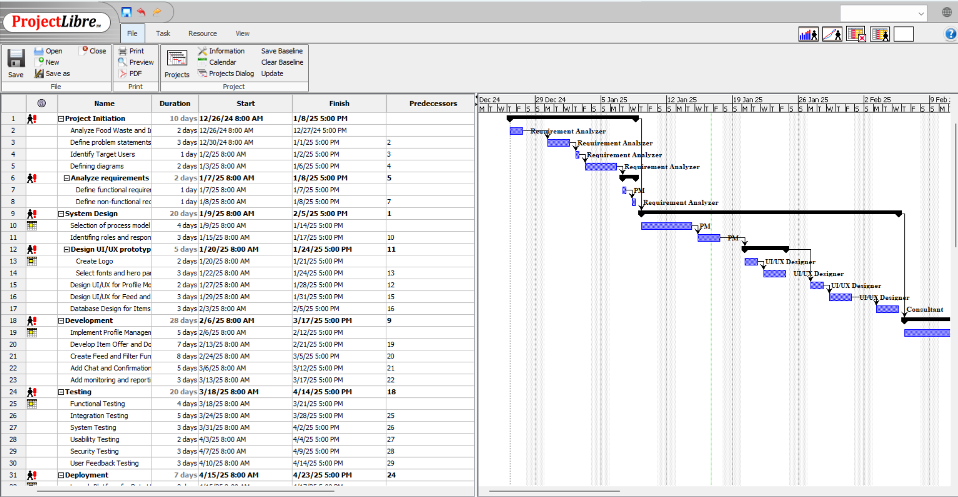3.1 ACTIVITY PLANNING

* 1. Resource Allocation
  2. A screenshot of a computer

     Description automatically generatedRisk Analysis

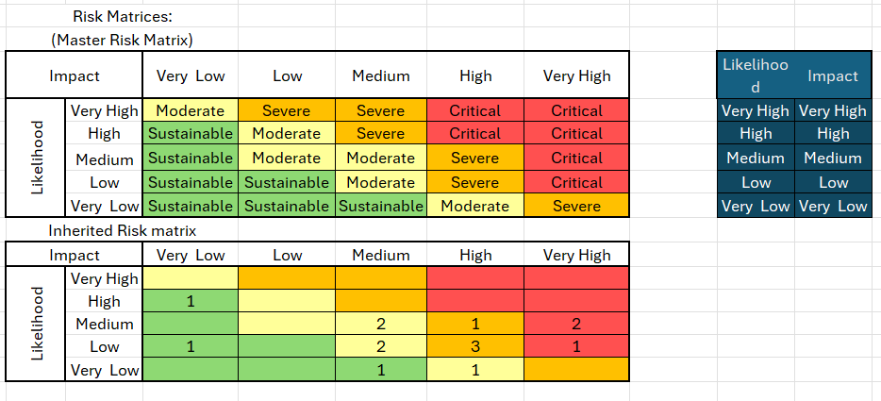

## Rubric for Project Assessment (CO3)

|  |  |  |  |  |  |
| --- | --- | --- | --- | --- | --- |
| Criteria | Marks distribution (Max 3X5= 15) | | | | Acquired  Marks |
| **Inadequate (1-2)** | **Satisfactory (3)** | **Good (4)** | **Excellent (5)** |
| Selection of Software Engineering Models | Does not articulate a position or argument of choosing appropriate model. Does not present any evidence to support the arguments for the choice of the model | Articulates a position or argument for choosing models that is unfocused or ambiguous. Presents incomplete/vague evidence to support argument for model choice | Articulates a position or argument of choosing models that is limited in scope. Does not present enough evidence to support the argument for the choice of the model | Clearly articulates a position or argument for the choosing software engineering models. Presents sufficient amount of evidence to support argument for the model selection |  |
| Role identification and Responsibility Allocation | The project has poor project management plans for identifying roles and assigning the responsibilities | Identify few roles in the project management where some of the roles are left alone with any project responsibilities | Identify most of the roles in the project management and assign their responsibilities | Well planned project with proper role identification and responsibility allocation in the project management activities |  |
| Impact identification |  |  |  |  |  |
| Formatting and Submission | Project report is not complete and Several errors in spelling and grammar. Present a Confusing organization of concepts, supporting  arguments, and  real-life example.  Sentences rambling, and details are repeated. | Some errors in spelling and grammar. Some problems  of organizing the answer in a logical order of defining,  elaborating, and providing real-life examples. | Few errors in spelling and grammar. Presents most of the details in a logical flow of  organization in  definition,  details, and  example. | Project report is complete and No errors in spelling and grammar. Consistently  presents a logical  and effective  organization of definition,  details, and real-life example of  the topic. |  |
| Acquired marks: | | | | |  |
| CO Pass / Fail: | | | | |  |

## Rubric for Project Assessment (CO4)

|  |  |  |  |  |  |
| --- | --- | --- | --- | --- | --- |
| Marking Criteria | Marks Distribution (Maximum 3X5=15) | | | | Acquired Marks |
| **Inadequate (1-2)** | **Satisfactory (3)** | **Good (4)** | **Excellent (5)** |
|  |  |  |  |  |  |
| Project Planning | No background information regarding the project is  given; project goals and benefits are  missing. | Insufficient background information is given; project goals and benefits are  poorly stated | Sufficient background information is given; the purpose and goals of the project are explained. | Thorough and relevant background information  is given; project goals are clear and easy to identify. |  |
| Effort Estimation and Scheduling | Student vaguely discuss the impact of societal, health, safety, legal and cultural issues in their project | Student provided with partial relevance to the impact of societal, health, safety, legal and cultural issues in their project | Student fairly provided the analysis to the impact of societal, health, safety, legal and cultural issues in their project | Student comprehensively provided the analysis to the impact of societal, health, safety, legal and cultural issues in their project |  |
| Risk Management | Ambiguous representative example. | Partially identify / indicate towards real-life example. | Real-life example is fairly connected towards the definition. | Comprehensively defend with real life example. |  |
| Acquired Marks: | | | | |  |
| CO Pass / Fail: | | | | |  |
|  | | | | |  |

|  |  |  |  |  |
| --- | --- | --- | --- | --- |
| **CO5 [PO-i-2]: Perform as an effective team member or leader in diverse team settings and solve multi-disciplinary problems in computer science and engineering domain.** | | | | |
| **Assessment Attribute/Criteria** | **Missing/ Incorrect (0)** | **Inadequate  (1)** | **Satisfactory (2)** | **Excellent (3)** |
| **Taking**  **responsibility** | Does not perform assigned tasks; often misses meetings and, when present, does not have anything constructive to say; relies on others to do the work; | Partially performs all assigned tasks; attends meetings irregularly and occasionally participates and hence not reliable; | Performs all assigned tasks; attends meetings regularly and usually participates effectively.  generally reliable; | Performs all tasks very effectively; attends all meetings and participates enthusiastically; very reliable. |
| **Contributions** | Never provides useful ideas when participating in a group discussion | Rarely provides useful ideas when participating in a group discussion | Sometimes provides useful ideas when participating in a group discussion | Routinely provides useful ideas when participating in a group discussion |
| **Collaboration and Ability to Compromise** | Not cooperative, unable to compromise and disrupts the team process. | Sometimes cooperative, and rarely displays a positive attitude. | Usually cooperative, able to compromise and generally display positive attitude. | Always cooperative. Willingness to compromise. Always display positive attitude. |
| **Valuing other**  **team members (Working with others)** | Often argues with teammates; doesn't let anyone else talk; occasional personal attacks and "put‐downs"; wants to have things done his way and does not listen to alternate approaches. | Seldom listens to others' points of view; occasionally behaves in an oppressive manner; tries to force their own ideologies on other. | Generally, listens to others' points of view; always uses appropriate and respectful language; tries to make a definite effort to understand others' ideas. | Always listens to others and their ideas; helps them develop their ideas while giving them full credit; always helps the team reach a fair  decision. |